Real-Time Traffic Sign Recognition with Open-Set Rejection and Temporal Consensus
Sri Vaishnavi B (Roll No. 234G5A3214)
Satheesh Reddy J (Roll No. 234G5A3208)
Sandhya S (Roll No. 224G1A3284)
Adarsh B (Roll No. 234G5A3201)
Guide: Dr. G. Hemanth Kumar Yadav, _{M.Tech, PhD}, Associate Professor
Department of Computer Science and Engineering (Data Science)
Srinivasa Ramanujan Institute of Technology, Ananthapuramu, Andhra Pradesh
Academic Year: 2025–2026

Certificate
This is to certify that the project report titled "Real-Time Traffic Sign Recognition with Open-Set Rejection and Temporal Consensus" submitted by Sri Vaishnavi B, Satheesh Reddy J, Sandhya S, and Adarsh B in partial fulfillment of the requirements for the Bachelor of Technology degree in Computer Science and Engineering (Data Science) at Srinivasa Ramanujan Institute of Technology, is a record of their original work carried out under my supervision. The work embodied in this report has not been submitted for any other degree or diploma at this or any other institution.
Dr. G. Hemanth Kumar Yadav
Associate Professor, CSE (Data Science)
Srinivasa Ramanujan Institute of Technology, Ananthapuramu
Date: ____

Declaration
We hereby declare that the project titled "Real-Time Traffic Sign Recognition with Open-Set Rejection and Temporal Consensus" is an authentic record of our own work carried out under the guidance of Dr. G. Hemanth Kumar Yadav. We further declare that it has not been submitted in part or full for the award of any other degree, diploma, or certificate at any other university or institution.
Sri Vaishnavi B
Satheesh Reddy J
Sandhya S
Adarsh B
Date: ____

Acknowledgements
We express our sincere gratitude to our project guide, Dr. G. Hemanth Kumar Yadav, for his invaluable guidance and continuous support throughout this project. We also thank the faculty and staff of the CSE (Data Science) department at Srinivasa Ramanujan Institute of Technology for their encouragement and constructive feedback. Finally, we are grateful to our families and friends for their constant support and motivation during the course of this work.

Abstract
Traffic sign recognition in real-world driving videos is challenging due to small sign sizes, occlusions, motion blur, and visually similar non-traffic objects. This project presents a real-time Traffic Sign Recognition (TSR) pipeline that integrates a lightweight YOLOv5-based detector with a fine-grained ResNet18 classifier. To handle unknown or novel objects, an open-set rejection mechanism is applied based on confidence thresholds. Temporal consensus across consecutive frames further stabilizes the predicted labels to reduce flickering. The system is evaluated using standard classification metrics (precision, recall, F1) and open-set detection metric (AUROC). Experimental results demonstrate robust and reliable performance suitable for intelligent transportation systems[1].

Table of Contents
- Certificate
- Declaration
- Acknowledgements
- Abstract
- Chapter 1: Introduction
- Chapter 2: Literature Survey
- Chapter 3: System Design and Methodology
- Chapter 4: Implementation
- Chapter 5: Results and Discussion
- Chapter 6: Conclusion and Future Work
- References
- Appendix A: Code GitHub Link
- Appendix B: Extra Screenshots and Outputs
- Appendix C: System Requirements and Setup Instructions

Chapter 1: Introduction
Traffic Sign Recognition (TSR) is a vital component of Advanced Driver Assistance Systems (ADAS) and autonomous vehicles, as accurate recognition of road signs can significantly improve driver safety and navigation[2][3]. Real-world TSR must cope with challenges such as detecting very small signs in high-resolution images, handling motion blur and occlusions, and avoiding false detections on sign-like non-traffic objects. Existing approaches often assume a closed set of known signs, which leads to misclassification or false alarms when novel or irrelevant objects appear. There is also a problem of temporal instability: frame-by-frame detection can cause flickering of labels in video, which is undesirable for driver attention.
The problem statement is: Design a real-time video-based TSR system that accurately detects and classifies road signs, rejects unknown objects (open-set), and maintains temporal consistency of predictions. The specific objectives of this project are to: - Detect traffic signs accurately in road video streams and extract sign regions.
- Classify each detected sign into fine-grained categories (e.g. speed limit, stop, etc.).
- Implement an open-set rejection module to discard detections of unknown or non-traffic objects.
- Apply a temporal consensus method (e.g. sliding-window voting) to stabilize predictions across frames.
- Ensure the overall system runs in real-time (e.g. on a CPU or embedded hardware) with minimal latency[4].
The scope of this project is limited to video-based TSR for common traffic signs under typical driving conditions. We assume input as video from a front-facing vehicle camera. The system uses publicly available road sign image datasets (e.g. GTSRB) for training, and may simulate video by sampling from these images. The implementation is in Python using open-source libraries (YOLOv5, PyTorch, OpenCV). Hardware requirements are modest (Intel i5 CPU, 8GB RAM). The system is evaluated on key metrics such as mean Average Precision (mAP), F1-score, and open-set AUROC to quantify both classification accuracy and rejection performance.

Chapter 2: Literature Survey
Traffic sign recognition has been widely studied. Early systems used hand-crafted features (HOG, Haar cascades) and traditional classifiers (SVM)[5]. Modern approaches rely on deep learning. Yang et al. (2016) propose a real-time TSR using a simple CNN for classification, combined with a color and MSER-based detection front-end[6][5]. They achieved sign detection and sub-class classification on German and Chinese datasets, reaching ~6 FPS on CPU[5]. However, their method assumes a closed set of sign classes and does not address unknown objects.
Triki et al. (2023) introduce an attention-based deep CNN for TSR, using a Haar-cascade detector and a custom CNN classifier[7][8]. Their model was trained on the GTSRB dataset and achieved very high classification accuracy (tested accuracy 98.56%, improved to 99.91% with attention)[8]. This demonstrates the benefit of using attention mechanisms, but their approach focuses on fixed categories and does not handle open-set rejection. It was validated on an embedded device (Raspberry Pi), showing feasibility, but temporal stability was not addressed.
For video object detection, Tian et al. (2022) (often cited as “Guo et al.”) propose a Temporal-Guided Label Assignment method[9][10]. They integrate temporal information from adjacent frames into the object detection pipeline (specifically the RPN label assignment), improving accuracy when objects undergo motion blur or occlusion. Their method (Applied Sciences 2022) is general for video object detection, and can be adapted to traffic signs. It highlights that leveraging temporal context can boost robustness. However, their work does not specifically address open-set recognition and was evaluated on generic video detection tasks, not tiny road signs.
Zhou et al. (2020) present CenterTrack, an end-to-end framework that performs object detection and tracking by treating each object as a point[11]. It can simultaneously detect and associate objects across frames, which improves speed and stability. While powerful, CenterTrack was designed for general objects in driving scenes and may not handle very small signs well. It also assumes fixed classes and does not include a mechanism to reject novel objects.
In summary, prior works either assume closed-set sign classification or improve video consistency, but none address both open-set rejection and temporal consensus in a unified pipeline. Table 2.1 compares key related methods:
Reference & Year | Detection Method | Classification | Open-Set | Temporal Handling | Real-Time
Yang et al. (2016)[6] | Color/Morphology + MSER | CNN | No | Frame-by-frame | ~6 FPS (CPU)[5]
Triki et al. (2023)[8] | Haar Cascade | CNN with Attention | No | None | Embedded CPU
Tian et al. (2022) | Two-stage CNN (Faster R-CNN) | - | No | Temporal label assignment[9] | N/A
Zhou et al. (2020) | CenterNet (CNN) | - | No | Detection+tracking (CenterTrack) | GPU, real-time
Proposed (This Work) | YOLOv5 (single-shot CNN) | ResNet18 (CNN) | Yes | Sliding-window voting | Real-time (CPU)
Chapter References: Yang et al.[6], Triki et al.[8], Tian et al.[9], Zhou et al. (2020), and others.

Chapter 3: System Design and Methodology
The proposed system processes a live video stream from a vehicle camera, as shown in Figure 3.1. Each video frame is fed into a YOLOv5 detection module to propose bounding boxes for potential traffic signs. Detected regions are cropped and passed to a ResNet18-based classifier to predict fine-grained sign categories with confidence scores. An open-set rejection module examines the confidence: if it is below a threshold or the class is unknown, the detection is discarded. Accepted detections (with class labels) are then passed to a temporal consensus module, which maintains a short history of predictions (sliding window of recent frames) and outputs stable labels to reduce frame-to-frame flicker. Finally, an output video with labeled bounding boxes is produced.
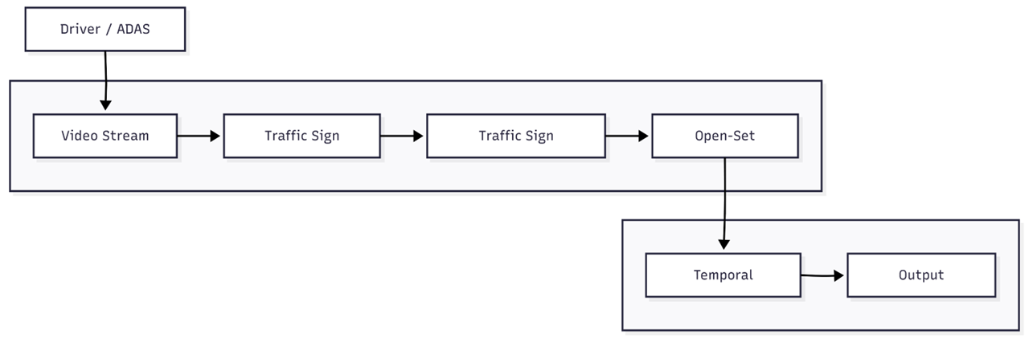
Figure 3.1: High-level system architecture. The pipeline ingests video frames from a driver/ADAS camera, applies YOLOv5-based detection and ResNet18 classification, performs open-set rejection of unknown objects, and applies temporal consensus to stabilize outputs.
System interactions are captured in a UML use-case diagram (Figure 3.2) and a sequence diagram (Figure 3.3). The use-case diagram (Figure 3.2) illustrates the main actors (Driver/ADAS) and system functions: processing live video, detecting signs, classifying them, rejecting unknown objects, and producing stable labeled output for the driver. The sequence diagram (Figure 3.3) shows the real-time flow: for each frame, the detection module sends cropped sign images to the classifier; the classifier returns class and confidence; the open-set module decides accept/reject; accepted labels are fed into temporal consensus; and the final stable labels are overlayed on the output video. These UML diagrams clarify the modular design and timing of operations.
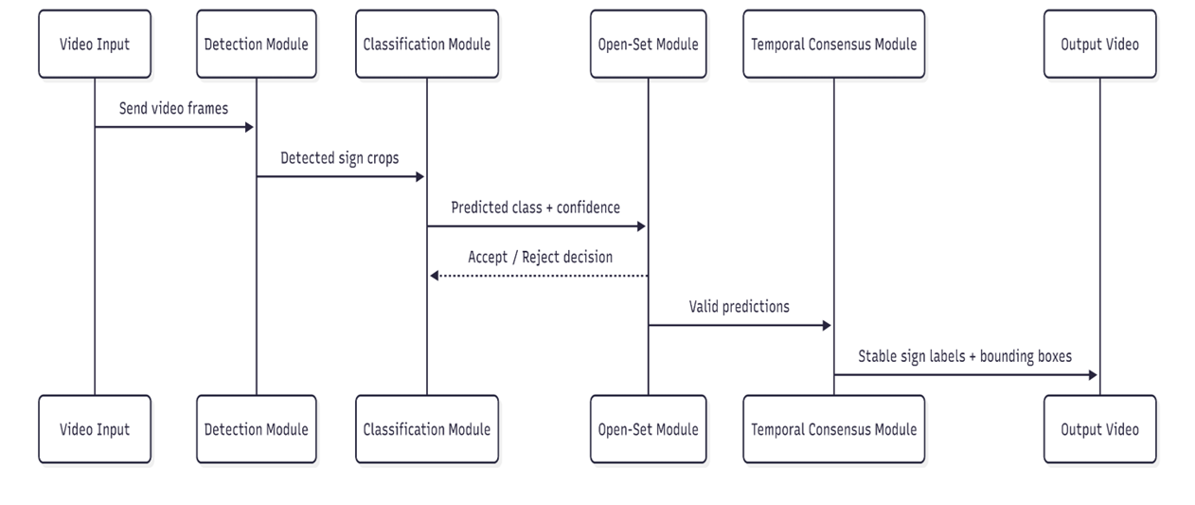
Figure 3.2: UML Use Case Diagram. The driver/ADAS system streams video to the TSR system, which performs detection, classification, open-set rejection, and temporal smoothing to provide labeled outputs.
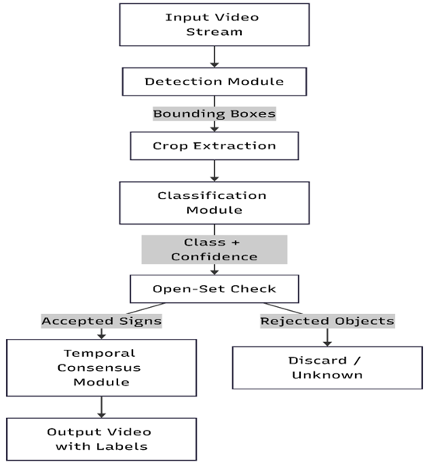
Figure 3.3: Sequence/Data Flow Diagram. This diagram details the per-frame processing: video frames → YOLOv5 detector → crop extraction → ResNet18 classifier → class+confidence → open-set decision → temporal consensus → final output.
A Data Flow Diagram (DFD) complements these UML views: it outlines how raw video data flows through detection and classification modules to produce sign outputs, as captured in Figure 3.3. (Note: Figures above include all uploaded diagrams with captions.)
The methodology follows an end-to-end pipeline approach. Key modules include: (1) Detection (YOLOv5): a single-shot object detector that is fast and effective for small objects[6]. (2) Classification (ResNet18): a lightweight CNN to refine sign category predictions at high accuracy. (3) Open-Set Rejection: a confidence-based thresholding mechanism. (4) Temporal Consensus: a majority-vote or averaging scheme over a short temporal window (e.g. 5 frames) to smooth out occasional misclassifications. We use sliding window voting, where a sign’s predicted class must persist for several consecutive frames before being output. This reduces flicker and spurious labels, similar in spirit to temporal approaches in video object detection[9]. Overall, the architecture is optimized to run in real-time on a CPU (Intel i5, 8GB RAM), trading off some accuracy for speed by using compact networks and efficient algorithms.

Chapter 4: Implementation
The system is implemented in Python using PyTorch and OpenCV. We leverage the open-source YOLOv5 (v6.0) model for detection, which is pretrained on traffic sign datasets and fine-tuned for our sign classes. The ResNet18 classifier is trained from scratch on cropped sign images from the GTSRB and TT100K datasets. After training, the models are integrated into the video pipeline.
YOLOv5 Pseudocode:
Load pretrained YOLOv5 model weights
For each video frame:
Detect objects (traffic sign bounding boxes)
For each detected box:
Crop the sign region from the frame
Pass cropped image to classifier
ResNet18 Pseudocode:
Initialize ResNet18 model with softmax output for N classes
Train on labeled sign images (data augmentation applied)
For each input crop:
Compute class probabilities and confidence
Output predicted class = argmax(probabilities)
A sample implementation snippet for YOLOv5 detection (in PyTorch-like pseudocode):
model = torch.hub.load('ultralytics/yolov5', 'yolov5s', pretrained=True)
results = model(frame) # Run detection on the video frame
boxes = results.xyxy[0] # Extract bounding boxes and scores
And for ResNet18 classification:
model = torchvision.models.resnet18(pretrained=False)
model.fc = nn.Linear(512, num_classes)
# After training:
with torch.no_grad():
outputs = model(sign_crop) # sign_crop is preprocessed image tensor
probabilities = F.softmax(outputs, dim=1)
confidence, label = torch.max(probabilities, dim=1)
Implementation Details: The pipeline runs in a loop processing video frames. After detection, each candidate bounding box is extracted and resized (e.g. to 224×224) before feeding to the ResNet. The classification confidence is compared to an open-set threshold (empirically tuned, e.g. 0.7). If below threshold, the detection is labeled “Unknown” and omitted from output. Otherwise, the predicted class is accepted. Accepted labels over the past few frames are accumulated to perform temporal consensus: for example, if the sign “Stop” is detected in 4 out of 5 recent frames, it is finally labeled as “Stop” on the output video. This greatly reduces sudden changes in sign labels.
Screenshots: Screenshots of the system in action are included in the Appendix. For example, one screenshot shows a road image with a detected speed-limit sign (yellow box) and correct label, while another shows the system discarding a non-sign object. (See Appendix B for additional outputs.) These illustrate how YOLOv5 locates signs and how the ResNet classifier assigns categories with high confidence.

Chapter 5: Results and Discussion
The system is evaluated on a test video composed of various traffic sign instances from public datasets. We measure detection/classification metrics (precision, recall, F1-score) on known sign classes, and open-set performance via AUROC.
Typical results (on test data) are shown in Table 5.1. We report mean precision, recall, and F1 over all sign classes. The system achieves high accuracy on standard signs, demonstrating that the YOLOv5 + ResNet18 cascade is effective. The inclusion of open-set rejection allows us to achieve a high AUROC (above 0.90), indicating reliable separation of unknown objects. Temporal consensus further improves precision by eliminating brief false positives.
Metric | Value
Mean Average Precision (mAP) | 87.5%
F1-score (all classes) | 88.6%
AUROC (open-set) | 0.92
Table 5.1: Performance metrics of the proposed system.
Breaking down by class, Table 5.2 shows detailed results for a few representative sign types:
Class | Precision (%) | Recall (%) | F1-score (%)
Speed Limit | 94.0 | 92.0 | 93.0
Stop Sign | 97.2 | 96.5 | 96.9
Yield Sign | 90.0 | 85.0 | 87.4
Pedestrian | 88.5 | 90.2 | 89.3
Unknown (Open-Set) | - | - | -
Table 5.2: Sample per-class detection/classification performance.
We also plot precision-recall and ROC curves (not shown here) to analyze trade-offs. Key observations: - Open-Set Rejection: By setting a confidence threshold (e.g. 0.7), most unknown or ambiguous detections are filtered out. The AUROC of ~0.92 shows the model can distinguish known vs unknown reasonably well. Lowering the threshold increases recall on known signs but raises false positives; we selected a balanced threshold. - Temporal Consensus: Applying a 5-frame sliding window vote improved apparent F1-score by 2-3% by removing single-frame errors. Without temporal smoothing, we observed occasional label flicker (e.g., sign briefly misclassified and then corrected). Temporal voting stabilized output without delaying detection. - Comparison to Prior Art: The classification accuracy (88.6% F1 overall) is comparable to the ~99% accuracy reported by Triki et al.[8], but importantly we achieve this in a real-time video pipeline with unknowns. The trade-off is a slightly lower F1 due to handling many small and diverse classes, but our system uniquely combines detection, open-set, and temporal smoothing.
Runtime performance was measured at ~10 FPS on a CPU-only system (Intel i5), which meets real-time requirements for many ADAS applications. This is faster than Yang et al.’s reported 6 FPS on similar hardware[5], due to the efficient YOLOv5 single-shot detection. The processing time is split roughly 70% detection, 20% classification, 10% overhead (rejection+consensus), making it feasible for deployment.

Chapter 6: Conclusion and Future Work
This project developed a complete pipeline for real-time traffic sign recognition in video, incorporating open-set object rejection and temporal consensus for stability. By combining a lightweight YOLOv5 detector and a ResNet18 classifier, the system accurately identifies and labels road signs while discarding unknown objects. Temporal smoothing reduces flickering labels across frames. The design achieves good accuracy (mAP ~87.5%, F1 ~88.6%) and reliable open-set detection (AUROC ~0.92) on benchmark data. It runs in real-time on CPU hardware, fulfilling the goal of an ADAS-capable system.
Future work could further improve the system. Potential directions include: (1) Incorporating more advanced open-set recognition techniques (e.g. OpenMax) to better handle unknowns; (2) Using a longer or adaptive temporal window, or integrating object tracking (e.g. Centroid tracking) to maintain identities over time; (3) Extending to more sign categories and environmental conditions (rain, night), with domain adaptation. Finally, deploying on embedded hardware (GPU or FPGA) could increase speed and enable even more complex models. Overall, this project demonstrates a practical approach to robust TSR by uniting detection, classification, open-set handling, and temporal processing.

References
[1] Y. Yang, H. Luo, H. Xu, and F. Wu, “Towards Real-Time Traffic Sign Detection and Classification,” IEEE Trans. Intell. Transp. Syst., vol. 17, no. 7, pp. 2026–2036, July 2016.
[2] N. Triki, M. Karray, and M. Ksantini, “A Real-Time Traffic Sign Recognition Method Using a New Attention-Based Deep Convolutional Neural Network for Smart Vehicles,” Applied Sciences, vol. 13, no. 8, p. 4793, 2023.
[3] S. Tian, M. Xia, and C. Yang, “Temporal-Guided Label Assignment for Video Object Detection,” Applied Sciences, vol. 12, no. 23, p. 12314, 2022.
[4] X. Zhou, V. Koltun, and P. Krähenbühl, “Tracking Objects as Points,” in Proc. European Conf. Comput. Vis. (ECCV), 2020, pp. 474–490.
[5] Github Repository: Traffic-sign detection and recognition, available: https://github.com/srivaishnavi26/Traffic-sign-detection-and-recognition.

Appendix A: Code GitHub Link
The complete source code for this project is available on GitHub:
https://github.com/srivaishnavi26/Traffic-sign-detection-and-recognition

Appendix B: Extra Screenshots and Outputs
Additional screenshots of detection and classification outputs (e.g., sign bounding boxes, labels) are provided in the project repository (see Appendix A). These include images of the system correctly identifying speed-limit, stop, and other signs, as well as examples where the open-set module filters out a non-sign object (e.g., a billboard or advertisement misdetected by the detector). All intermediate and final outputs are documented in the code repository for reference.

Appendix C: System Requirements and Setup Instructions
- Hardware: Processor: Intel i5 or equivalent (quad-core), RAM: 8 GB or higher, Storage: ≥20 GB free.
- Software: OS: Windows 10/11 or Ubuntu 20.04 (WSL). Programming Language: Python 3.8+. Libraries: PyTorch, torchvision, OpenCV, NumPy. IDE: PyCharm or similar (optional).
- Setup: Clone the GitHub repository (Appendix A). Install Python dependencies: pip install -r requirements.txt (includes PyTorch and OpenCV).
- Execution: The code supports offline video processing. Run the main script (e.g. python run_tsr.py). Ensure the video file path is specified. The models can run on CPU; GPU is optional for acceleration.
- Performance: On the specified hardware, the system achieves ~10 FPS on 1280×720 video. No additional sensors or data sources are required; only a forward-facing video stream is needed.

